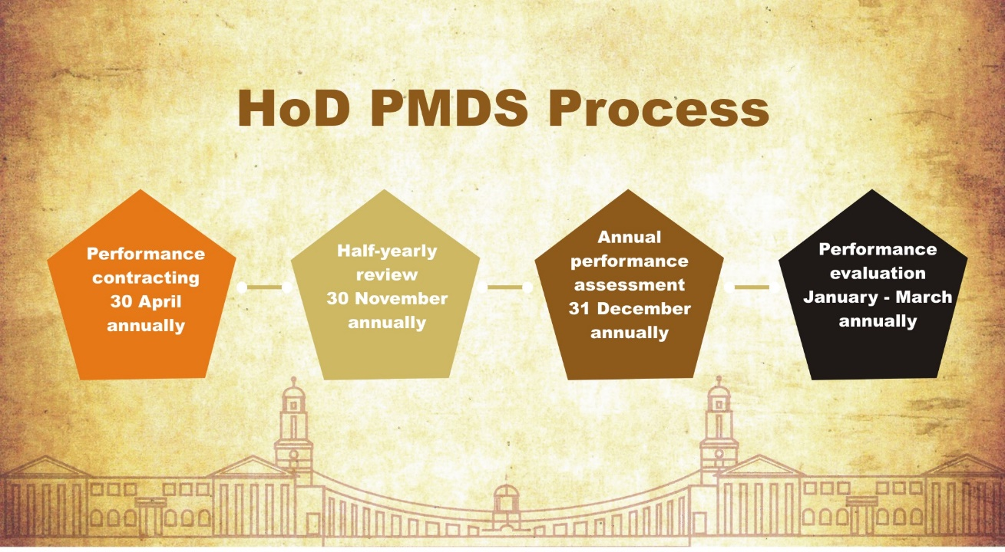
Welcome to Heads of Department Performance Management
The Directive on the Performance Management and Development System (PMDS) for Heads of Department (HoDs) was issued by the MPSA in terms of section 41(3) of the Public Service Act, 1994 and came into effect from 1 April 2018. There are four phases in the Heads of Department Performance Management process. The first phase requires that all Directors-General (DGs) and HoDs enter into and sign a performance agreement (PA) with the relevant Executive Authority (EA). The signed copy of the performance agreement must be submitted to the Department of Planning Monitoring and Evaluation (DPME) on or before the 30 April of each financial year. Newly appointed or transferred DGs/HoDs must conclude and sign their performance agreements within three months from their date of appointment. In the event of National and Provincial elections occurring within the first three (3) months of any financial year, HoDs must sign and file their PAs with the DPME for that financial year, within three (3) months following the month of the elections. This period will enable HoDs to review and make the necessary amendments that may emanate from the changes of the government priorities which impact on the Annual Performance Plan.
The second phase of the process is the completion and submission of the half-yearly review. This must be submitted to the DPME on or before the 30 November of each year.
The third phase is the completion and submission of the annual performance assessment. The annual performance assessment must be submitted to the DPME on or before the 31 December of each year.
The fourth phase of the HoD PMDS process is the annual evaluation which takes place between January and March of each year. If the DG/HoD has less than 12 months in the post he/she would still be assessed and the evaluation panel would take into account, the period of service when evaluating their performance category.

